For the work efficiency and effectiveness, please fill out the part with signal “*” on the below items
Basic Information
When to Inspect? |  | Where (country) to Ship?
Client’s Information |  | Supplier’s Information
Company |  | Company
*Attn. |  | *Attn.
*WhatsApp / Wechat |  | *Mobile Number
*Email |  | Address
Country |  | Website
Product Information
*Product Name | Acoustic foam | *Order No.
*Order Qty. | 10000 | Item No.
Inspection Location |  | *Material / Thickness
*Main Prod. Color |  | *Main Prod. Size

*Service Required (Please click the box to choose the service you required)
 | During Production Inspection |  | Factory Audit
 | (PSI) Pre-shipment Inspection (AQL Random Sample) |  | Loading Supervision
 | 100% Inspection (Full Order quantity) |  | Re-inspection

If any, please state your product check point(s) in below:
- Do not perform a carton drop test.
- Compare products with our red tape master sample. Make sure the color and texture is the same. Please take photos and videos to share.
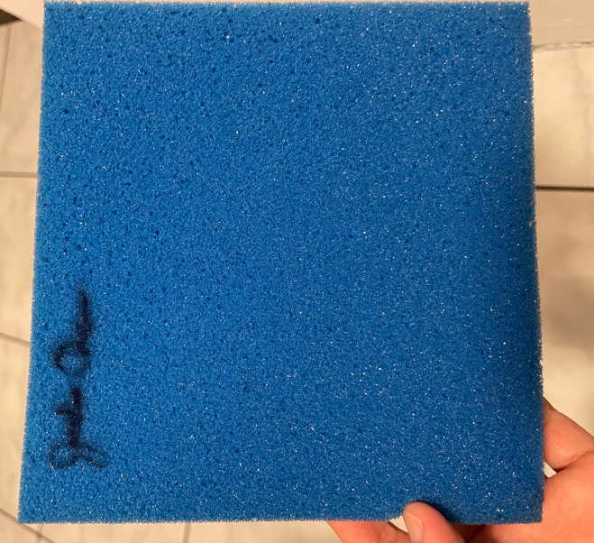
- Make sure products are the correct size. Submerge in water to expand the foam to full shape before measuring.
- Each product comes with 3 inserts:
- Xxx

If any, please insert your product photo(s) in below:
FNSKU barcode picture |  | FBA shipping barcode picture
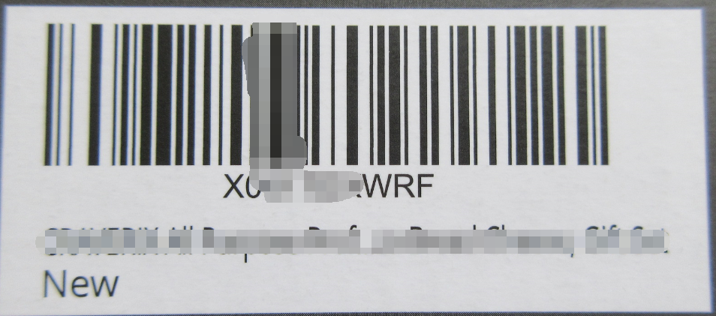 |  | 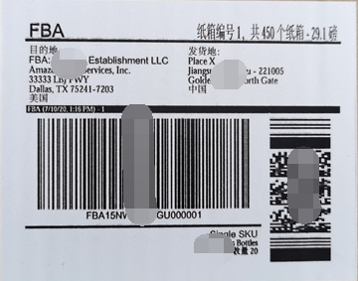
In order to conduct a successful inspection, please provide clear and sufficient information to us. Please click the box to indicate what you have provided.
 | Purchase Order/ Contract / Proforma Invoice |  |  | Approval samples
 | Product specification |  |  | Working instruction sheet
 | Digital photos |  |  | Others:

We declared that the above information given by us is true and correct. We agree that the inspection will be carried out in accordance with an agreed inspection plan and Qualityloyal Inspection Service has the full discretion to carry out the inspection. We agree that the Report or Inspection Certificate is issued on the understanding that it cannot form the basis of, or the instrument for, any legal liability against Quality Loyal Inspection.
Authorized signature and company chop | ABB Import LLC
Printed Name and Position |  | Date

